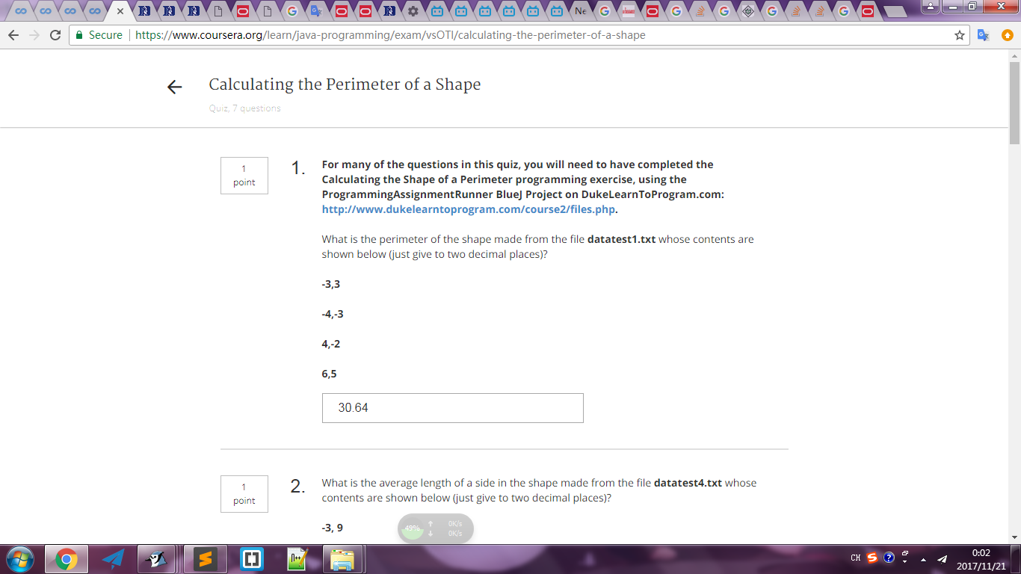
getNumPoints = 4 4
getAverageLength = 7.661168656292543 7.66
getLargestSide = 12.806248474865697 12.81
getLargestX = 6.0 6
getPerimeter = 30.644674625170172 30.64

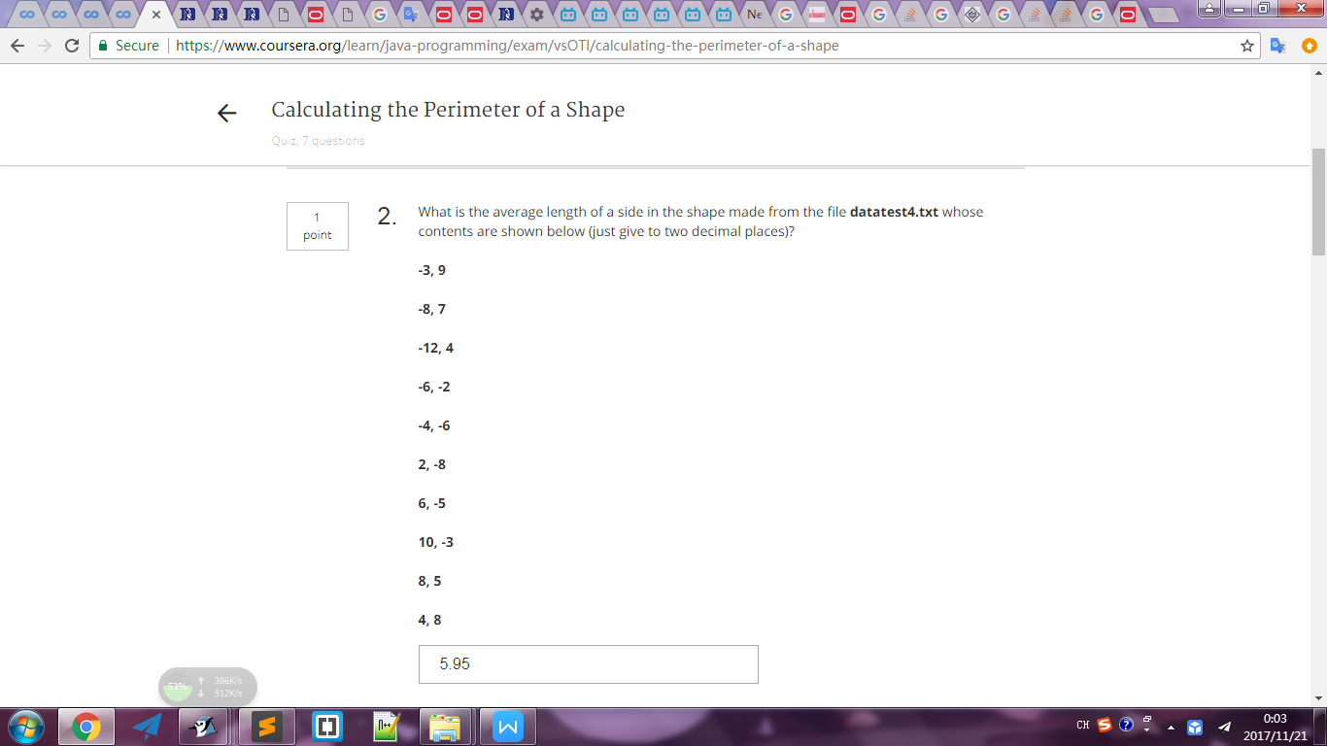
getNumPoints = 10 10
getAverageLength = 5.945655247480979 5.95
getLargestSide = 16.492422502470642 16.49
getLargestX = 10.0 10
getPerimeter = 59.45655247480979 59.46

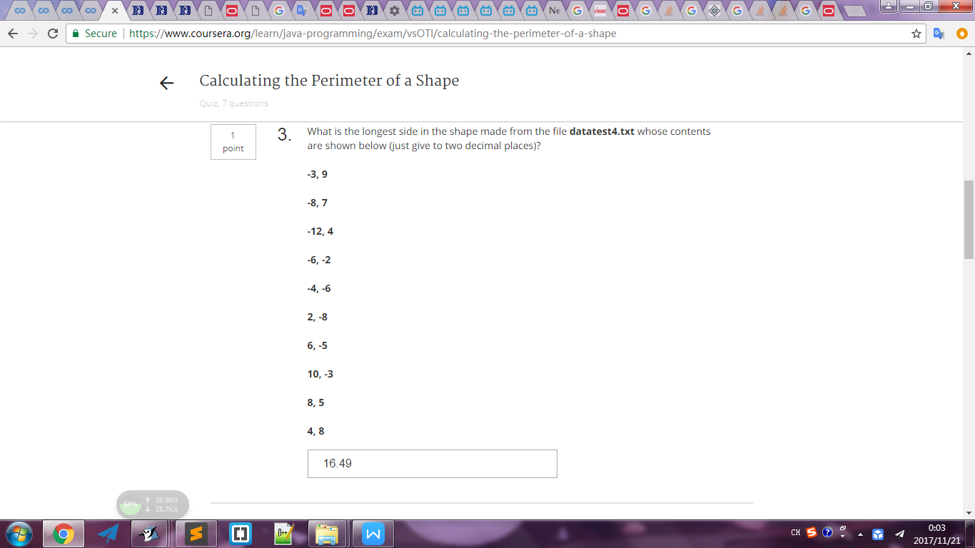
getNumPoints = 10 10
getAverageLength = 5.945655247480979 5.95
getLargestSide = 16.492422502470642 16.49
getLargestX = 10.0 10
getPerimeter = 59.45655247480979 59.46

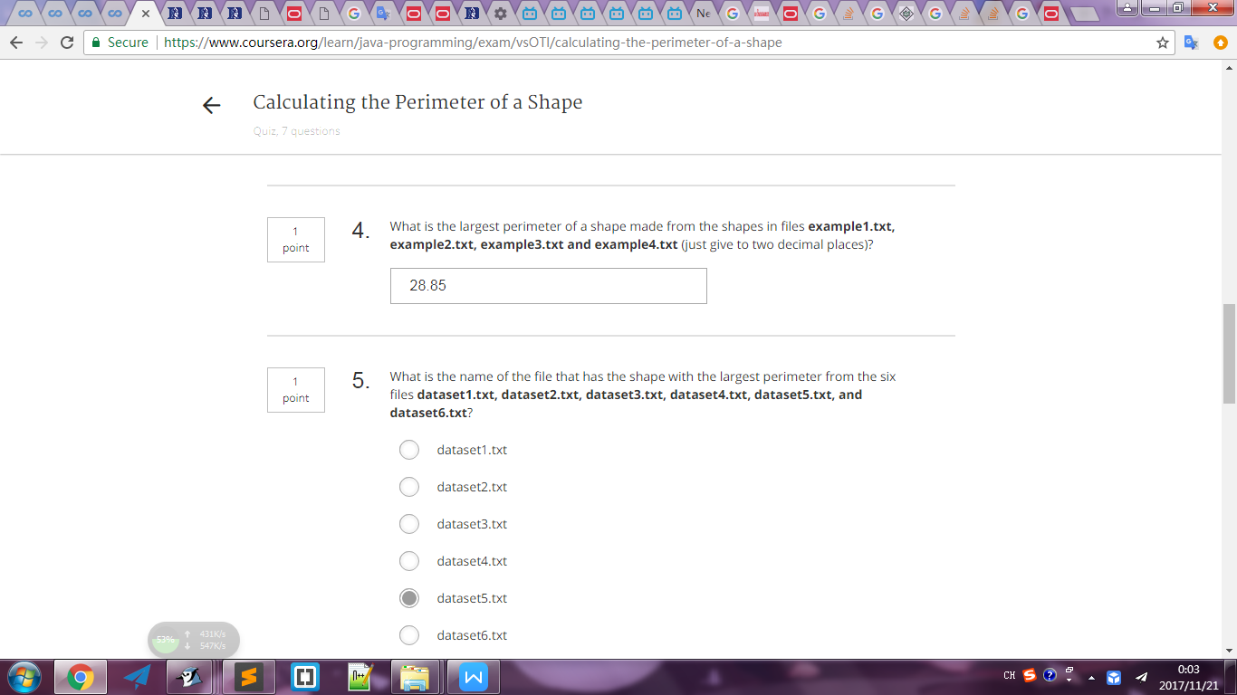
getPerimeter = 16.0 16
getPerimeter = 24.0 24
getPerimeter = 28.848857801796104 28.85
getPerimeter = 23.18423680063111 23.18

getLargestPerimeterMultipleFiles = 28.848857801796104 28.85
getFileWithLargestPerimeter = example3.txt

getLargestPerimeterMultipleFiles = 62.650940590154335 62.65
getFileWithLargestPerimeter = datatest5.txt

